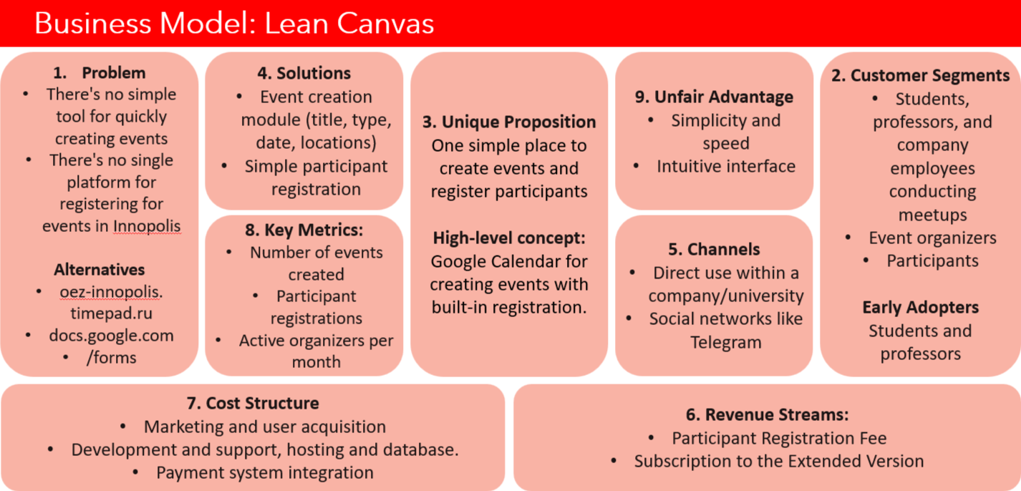

Unit Economics (Model):
We use approximate data for our calculations. Assume:
- Innopolis hosts approximately 100 events per month.
- Only 30% of events are paid → 30 paid events / month.
- Average ticket price: 2,000 ₽.
- Average number of registrations per paid event: let's say 20 people.
Organizer revenue: 40,000 ₽ / event.

The service only makes money from organizers:
- PRO subscription:
- Price: 1,000 ₽ / month.
- Commission: 3% of each paid ticket.
- Unlimited number of events.
- Basic plan (without subscription)
- Commission: 5% of tickets.
- Limit: up to 3 events / month.
- Free events
- Commission = 0 ₽.

Let's assume the distribution of organizers:
• 30% use PRO → 9 events/month
• 70% use BASIC → 21 events/month

About expenses:
- Advertising: 2,000 rubles once for 6 months → ≈333 rubles per month.
- Payment system fees:
- Fast Payment System: 1.8%
- Russian bank cards: 2.5%
- So, Average: 2.2%.
Revenue:
 | PRO version | Basic Version
Revenue per ticket (Ticket Unit) | Service commission = 3% of 2,000 ₽ = 60 ₽ | Service commission = 5% of 2,000 ₽ = 100 ₽
Revenue per event (Event Unit) | 20 tickets x 60 ₽ = 1,200 ₽ | 20 tickets x 100 ₽ = 2,000 ₽
Monthly income | 9 × 1200 = 10,800 ₽  + subscriptions: 9 × 1000 = 9,000 ₽  Total: 19,800 ₽ | 21 × 2000 = 42,000 ₽
Monthly income | 19,800 + 42,000 = 61,800 ₽

Cost:
Payment system commission (2.2%) | 30 paid events x 20 people x 2,000 ₽ = 1,200,000 ₽ turnover  Commission:  1,200,000 x 0.022 = 26,400 ₽ / month
Advertising | 2,000 rubles every six months → 333 rubles/month.
Servers, hosting, data processing | We'll assume: 1,000 rubles/month
TOTAL expenses per month | 26,400 ₽ + 1,000 ₽ + 333 ₽ = 27,733 ₽ / month

Monthly profit = 61 800 ₽ - 27 733 ₽ = 34 067 ₽/ month

Unit Economics for each unit:
One ticket | Average commission ≈ (3% × 0.3 + 5% × 0.7) = 4.4%  Revenue per ticket = 2,000 × 0.044 = 88 ₽  Payment commission: 2,000 × 0.022 = 44 ₽  Profit: 88 – 44 = 44 ₽ net profit per ticket
One Paid Event | Average PRO revenue = 1,200 ₽ × 0.3 = 360 ₽  Average BASIC revenue = 2,000 ₽ × 0.7 = 1,400 ₽  Total average revenue = 1,760 ₽ / event  Expenses:  40,000 ₽ turnover × 0.022 = 880 ₽  Profit:  1,760 – 880 = 880 ₽ profit from one paid event
One PRO Organizer | Income:  1,000 ₽ subscription + 4 events/month × 1,200 ₽ = 1,000 + 4,800 = 5,800 ₽  Expenses:  Turnover: 4 × 40,000 = 160,000 ₽  Commission 2.2% = 3,520 ₽  Profit:  5,800 – 3,520 = 2,280 ₽ / month per PRO Organizer

Key Metrics:
Profit per Ticket | 44 ₽
Profit per Paid Event | 880 ₽
Profit per PRO Organizer | 2,280 ₽
Monthly Revenue | 61,800 ₽
Monthly Costs | 27,733 ₽
Monthly Profit | 34,067 ₽

